Cara run:

---------------

dedi@dedi-HP-Notebook:~/Tugas/praxis-academy/novice/03-03/latihan/latihanMicronautFirst/gradle/complete$ gradlew run

Starting a Gradle Daemon, 1 busy Daemon could not be reused, use --status for details

> Task :run

14:56:46.524 [main] INFO io.micronaut.runtime.Micronaut - Startup completed in 1488ms. Server Running: **http://localhost:8089**

<=========----> 75% EXECUTING [24s]

> :run

Hasil Tampilan dan akses :

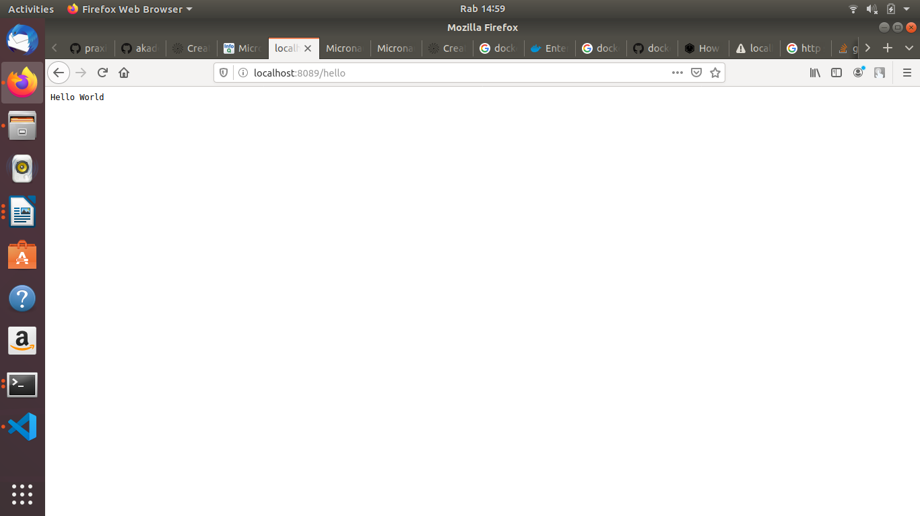

Hasil Test dengan Junit5

